Introduction
The dataset contains 100 observations, one grouping factor with six levels, and 11 quantitative morphometric traits used to evaluate relationships among traits and overall multivariate structure.
The main objectives were to standardize the morphometric variables, identify statistically significant Spearman correlations among traits, perform principal component analysis (PCA), and visualize the PCA structure with respect to the grouping factor. The analysis also required an interactive three-dimensional PCA biplot based on the first three principal components.
Methods
The dataset was imported into R, and the first column was treated as a grouping factor while the remaining 11 columns were treated as numeric morphometric variables. To avoid encoding problems and improve readability, the variable names were standardized into English labels for analysis and figure production.
Before multivariate analysis, the numeric traits were standardized using range normalization so that all traits would be comparable in scale. This step ensured that traits measured on different numeric ranges contributed more fairly to the PCA.
Spearman rank correlation coefficients were then calculated between all pairs of morphometric traits, and only statistically significant associations at p<0.05p<0.05 were retained in the final correlation table. PCA was subsequently performed on the standardized trait matrix to reduce dimensionality and summarize the dominant patterns of variation in the morphometric data.
The PCA results were visualized in three ways: a two-dimensional biplot with points coloured by group and without ellipses, a second two-dimensional biplot with 95% confidence ellipses for each group, and an interactive three-dimensional PCA biplot based on PC1, PC2, and PC3 with loading vectors.
Results
Significant correlations
The correlation analysis showed that many morphometric traits were significantly and positively related to one another. This indicates a coordinated morphometric structure in which increases in some vegetative or floral dimensions tend to be accompanied by increases in other dimensions.
Among the strongest significant positive correlations were:
- length_first_leaf and length_second_leaf, r=0.944r=0.944
- length_outer_perianth and length_inner_perianth, r=0.924r=0.924
- width_outer_perianth and width_inner_perianth, r=0.879r=0.879
- width_first_leaf and width_second_leaf, r=0.797r=0.797
These strong associations suggest that leaf dimensions and floral dimensions vary in a highly coordinated way across the sampled individuals. Such correlation structure supports the use of PCA, because PCA is particularly informative when variables are interrelated.

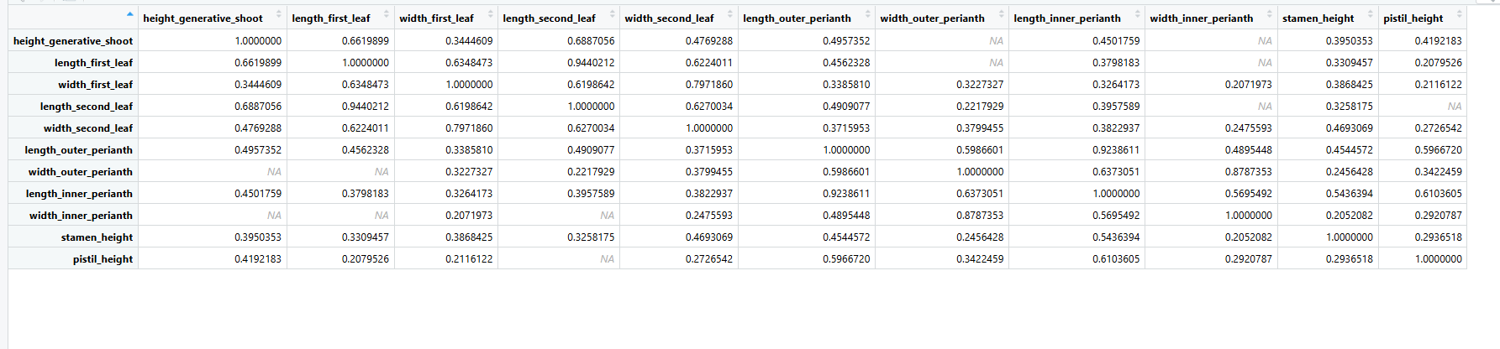Figure 1. Significant Spearman correlation coefficients (p<0.05)(p<0.05) among the morphometric traits.

PCA variance structure
The PCA results showed that the first principal component explained 51.01% of the total variance, the second explained 17.20%, and the third explained 10.32%. Together, the first two principal components explained 68.22% of the total morphometric variation, while the first three explained 78.54%.
This means that the PCA achieved a strong reduction in dimensionality while still preserving most of the information contained in the 11 standardized morphometric variables. Therefore, both the two-dimensional and three-dimensional PCA visualizations are informative representations of the dataset.
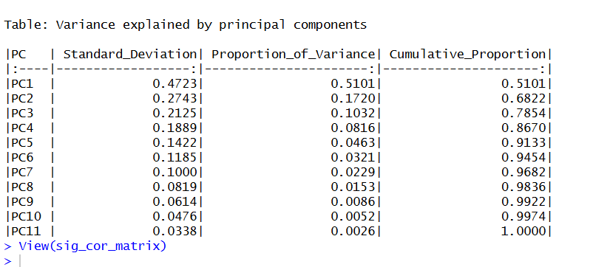 Figure 2 - Variance explained by the principal components of the standardized morphometric dataset.

PCA biplot without ellipses
The PCA biplot without ellipses displays the observations in the space of the first two principal components and shows the directions of the variable loadings. The first axis, Dim1 or PC1, explains 51% of the variance, while Dim2 or PC2 explains 17.2%, giving a total of 68.2% for the two-dimensional representation.
The trait vectors indicate that several leaf and floral measurements contribute strongly to the positive direction of PC1. In particular, length_outer_perianth, length_inner_perianth, width_first_leaf, and length_second_leaf appear to be among the more influential variables in defining the main PCA structure, which suggests that PC1 largely reflects a broad morphometric size gradient.
The group points show some tendency toward clustering, but they also overlap noticeably in the two-dimensional PCA space. This suggests that the groups differ to some extent in morphology, but not so strongly that they become completely separated on the first two axes alone.
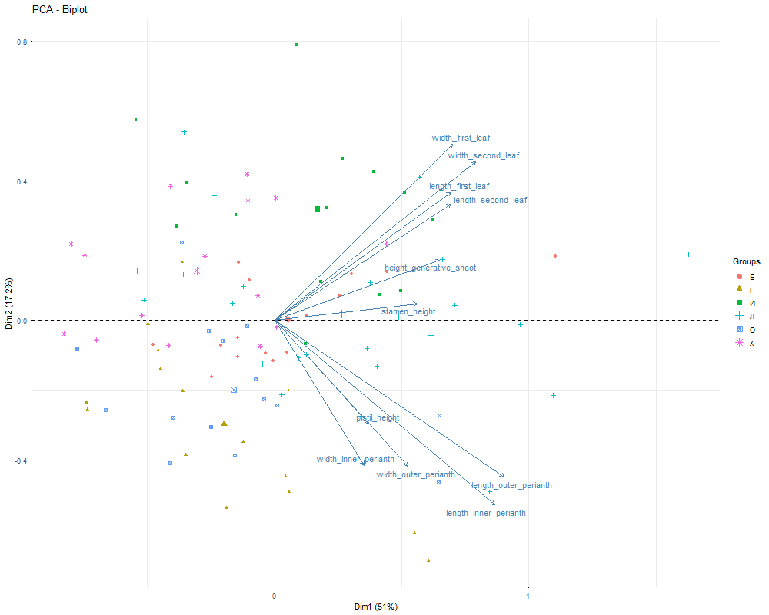
Figure 3. PCA biplot of standardized morphometric traits with observations coloured by group, without confidence ellipses.

PCA biplot with 95% confidence ellipses
The PCA biplot with 95% confidence ellipses provides a clearer view of group-level distribution than the plot without ellipses. The ellipses show that although some groups tend to occupy slightly different regions of the PCA space, there is still substantial overlap among several groups.
This overlap indicates that the first two principal components do not provide complete discrimination among all six groups. In other words, morphometric differences among groups are present, but they are only moderate in the two-dimensional PCA representation.
The ellipse-based plot is particularly useful because it summarizes within-group spread and between-group overlap more clearly than a point-only biplot. Based on this figure, the most reasonable interpretation is partial clustering with incomplete separation.
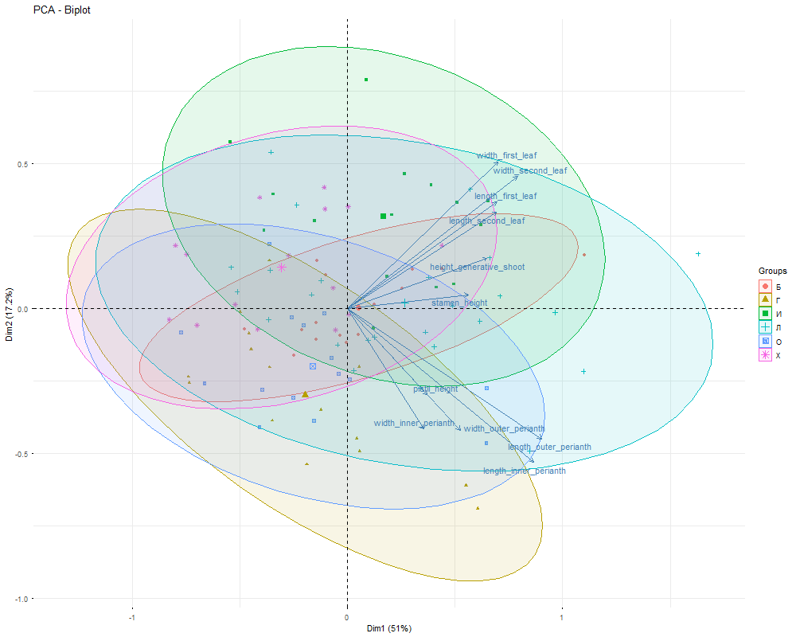
Figure 4. PCA biplot of standardized morphometric traits with observations coloured by group and 95% confidence ellipses.
Interactive 3D PCA biplot
The interactive 3D PCA biplot was generated using PC1, PC2, and PC3 and includes both observation scores and loading vectors. Because the first three principal components explain 78.54% of the total variance, the three-dimensional representation captures substantially more of the total morphometric variation than the two-dimensional plots.
The loading structure for the first three principal components indicates that traits such as length_outer_perianth, length_inner_perianth, width_first_leaf, and length_second_leaf are important contributors to the overall PCA configuration. This supports the interpretation that variation in both floral and leaf size measurements is central to the multivariate structure of the morphometry dataset.
In practice, the interactive 3D plot allows better inspection of how the observations are distributed across the first three axes and how the loading vectors orient in space. Since MS Word cannot embed a live interactive HTML object, this figure should be submitted as a supplementary file together with the report.
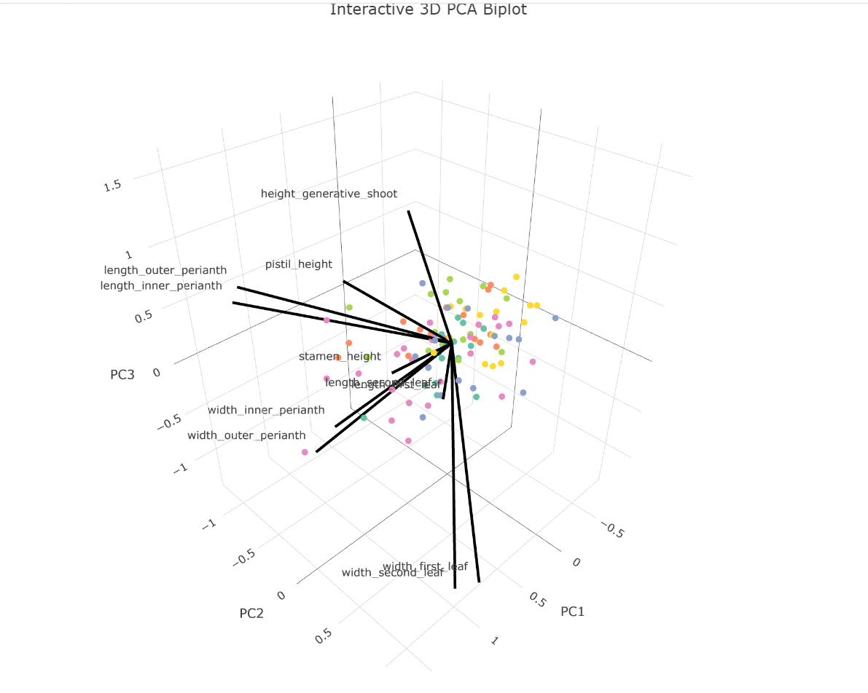Figure 5. Interactive 3D PCA biplot (PC1, PC2, PC3) with observation scores and loading vectors.

Interpretation
The PCA results show that a large proportion of the total morphometric variation can be summarized by a small number of principal components. The first principal component is the dominant axis and appears to represent a general size-related gradient involving both vegetative and floral measurements.
The second and third principal components add more detail to the structure, but they explain much less variance than PC1. Even so, including PC3 in the interactive visualization improves the ability to inspect group structure beyond the two-dimensional PCA plots.
The confidence ellipses and point distributions indicate that the groups are partially separated but not completely distinct in PCA space. Therefore, the morphometric traits contain group-related variation, but the separation is not strong enough to produce fully isolated clusters on the first two principal components.
The strong correlations among leaf and perianth traits, together with their substantial PCA loadings, suggest that these variables vary in an integrated manner across individuals. This coordinated variation is a key feature of the dataset and explains why PCA was effective in reducing dimensionality while preserving biologically meaningful structure.

Conclusion
The required analysis of the morphometry dataset was successfully completed. Range normalization produced a standardized trait matrix suitable for multivariate analysis, significant Spearman correlations revealed numerous positive relationships among morphometric variables, and PCA provided an effective low-dimensional summary of the main patterns of variation.
The first two principal components explained 68.22% of the total variance, while the first three explained 78.54%, showing that most of the variation in the 11 morphometric traits could be summarized by a few dominant axes. The PCA biplots showed partial but incomplete group separation, and the loading vectors indicated that leaf and perianth traits were among the most influential contributors to the main axes of variation.
Overall, the morphometric dataset shows a structured pattern of coordinated trait variation, with moderate group differentiation and strong interrelationships among several floral and leaf measurements.

